Job Description: Senior Administrator

Post title and post number | Senior Administrator
College/Budget Centre | Precision Health Technologies Accelerator Ltd
Full time/Part time | Full Time
Duration of the Post | Open
Salary | £24,000 - £26,000
Additional information | Bonus scheme + generous holiday allowance
Terms and Conditions | PHTA Ltd
Closing Date | Friday 15th October 2021
UoB Equivalent Job Family Framework | Administrative
UoB Equivalent Grade | 500

Job context
The University of Birmingham is leading transformational change in the region’s health and life sciences innovation ecosystem that will deliver significant and long-lasting improvements to the health and wealth, of the region and nationally.
Working as Birmingham Health Partners (BHP), the Midland’s leading academic-NHS partnership, the University is building on BHP’s nationally recognised strengths in healthcare data informatics and systems; genomics medicine and diagnostics; medical technologies evaluation and clinical trials, to establish the Precision Health Technologies Accelerator (PHTA) – the anchor innovation capability on the new Birmingham Health Innovation Campus.
The PHTA will provide the early incubation, grow-on space and innovation services for businesses working across biopharma (including advanced therapies), diagnostics, digital health and advanced healthcare technologies to accelerate the development and delivery of new precision drugs, diagnostics and healthcare technologies into the clinic. Run and operated by PHTA Ltd, a wholly owned subsidiary company of the University of Birmingham, PHTA will deliver a commercially-focused, innovative end-to-end clinical and academic partnership for the delivery of precision medicine solutions.
Job summary
As the senior administrator for the PHTA Ltd, you will provide support for a broad range of administrative duties, some of which may be complex including administration of financial transactions. You will be responsible for supporting colleagues within the PHTA Ltd, providing day to day operational support and sharing knowledge across the PHTA Ltd and with colleagues within the University. Notably you will work closely with the Managing Director, supporting them in a wide range of administrative tasks and setting up of administrative systems for the company. You will also take on a number of the administrative responsibilities for the company on behalf of the Company Secretary. You will be able to use your wide range of skills, both technical and administrative, and have the opportunity to lead on specific tasks within a small but growing team.
Organisation chart
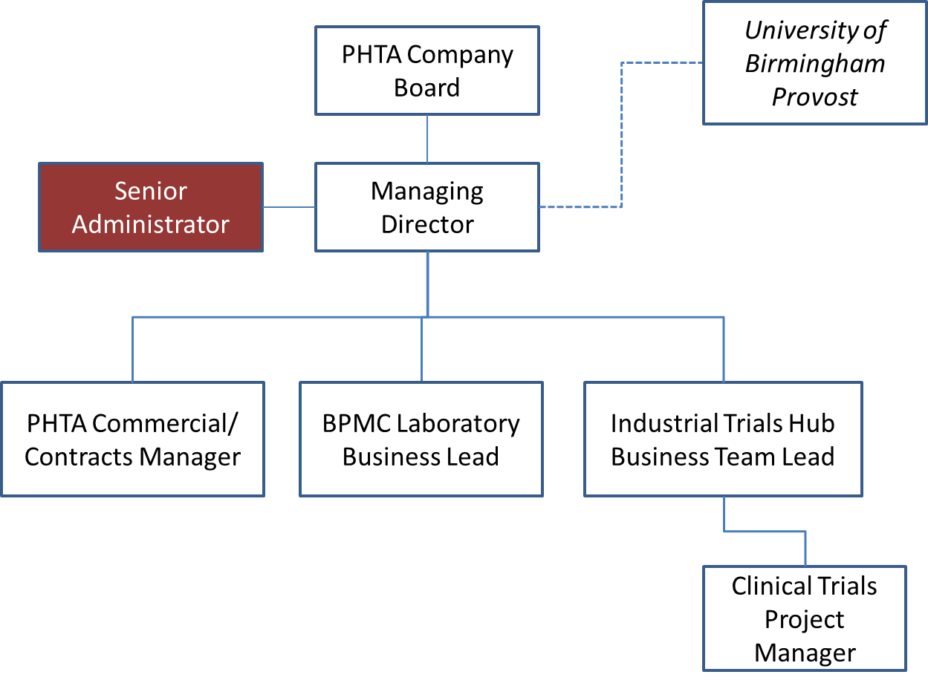

Main duties
- Support the management, development and implementation of operational administrative processes and systems for the PHTA Ltd.
- Provide executive support to the Managing Director including:
  - Managing diary commitments and scheduling meetings
  - Making appropriate travel arrangements
- Establish and maintain a real / virtual files/folders system
- Provide key administrative Company Secretary functions in support of the business, including:
- Setting schedule of meetings (annual basis), for Company Board and additional committees (e.g. Audit Committee, Remuneration Committee) and any other company meetings.
- Draft agenda for Board/Committee meetings with MD and follow up with authors of board papers and circulate agenda and papers to Board/Committee members at least one week prior to meetings
- Attend and provide a professional secretarial service, including maintaining records of attendance and recording of minutes, of all Company meetings
- Ensure all company correspondence with Companies House is completed on time, including Annual Return, Annual Accounts, Appointment/Resignation of Directors
- Maintain a record of all Directors annual fraud declarations/register of interests/related third party transactions.
- Compile monthly Operations Report as required by the MD and in a format to be agreed. This may include any KPI or output reporting for external parties (such as funders)
- Provide administration of financial transactions
- monitoring budgets including processing payments, authorising expenditure, raising concerns where finances are not in line with the budget
- payment of supplier invoices and raising invoices for PHTA customers, ensure all invoices, and other payment requests are checked with reference to University guidelines and are duly authorised by budget holders and entered onto financial system promptly and accurately.
- ensure invoices are received, approved and processed for direct bank payments (i.e. direct debits, CHAPS payments and similar payments).
- supplier Maintenance – Bank details, remittance.
- reconcile supplier statements to ensure all liabilities recognised
- handle and resolve queries from both suppliers and internal departments.
- keeping record of all financial transactions in a systematic way to ensure records can be passed to relevant Accountant for completing statutory returns
- You may be required to be responsible for one or more of the following:
- procuring goods and services either directly or through liaising with University colleagues and via the University or through PHTA systems
- updating and writing contents for the department’s communications e.g. intranet pages,
- dealing with health and safety and facilities issues,
- HR-related tasks such as managing staff absence, induction, or dealing with leavers
- monitoring internal procedures/compliance and ensuring these are followed and disseminated as appropriate.
- organising events, including booking a venue, sending invitations, arranging refreshments, liaising with speakers, manage bookings, co-ordination of colleagues, advertising, collating feedback and reporting back.
- Maintain high quality, professional working relationships with:
- key external stakeholders, fielding enquiries and ensuring that appropriate information is disseminated to stakeholders as appropriate.
- key University partners and stakeholders in order to support and facilitate transactions necessary for the operation of the business, field enquiries and disseminate accurate and timely information as appropriate.
- You will likely manage some smaller projects on own initiative, but will also carry out desk research and source data from internal and external sources in order to contribute to wider projects.
- You will be expected to exercise your judgment on the answer to queries or on the direction of work within parameters set by your manager. On a day to day basis you will be expected to resolve more complex queries without necessarily referring to your manager.
Required Knowledge, Skills, Qualifications, Experience
- Educated to A Level standard, or equivalent level 3 qualification such as a Level 3 NVQ, or level 3 national diploma or relevant work experience evidencing the skills and ability to undertake the role.
- Minimum of grade C in Mathematics and English at GCSE or equivalent.
- Professional experience in a similar role
- Ability to handle financial administration and keep systematic records of financial transactions
- Highly proficient IT skills, in particular the ability to handle complex electronic diaries and emails, the wider MS Office suite of programmes including Word, Excel and Powerpoint, and some experience of using an enterprise resource planning package. The post holder should also be confident and able to quickly learn new IT skills and software packages as required.
- Proven ability to plan ahead and anticipate requirements, proactively planning own (and sometimes others’ workloads) to manage time effectively, progress tasks concurrently and work to deadlines.
- Excellent verbal and written communication skills, including the ability to write for different audiences, and to required deadlines.
- Excellent interpersonal skills. The postholder must inspire confidence and command authority with a range of colleagues and provide excellent customer service at all times.
- A high degree of professionalism, tact, and diplomacy, and the ability to exercise discretion regarding the handling and management of sensitive information/issues.
- A high degree of initiative, personal judgement, resourcefulness, flexibility, and a self-motivating approach.
- Able to familiarise oneself with complex systems and procedures and be confident in offering advice on these.
- Ability to work effectively in both small teams and within a large, complex organisation.
- Ability to understand policy and procedures and how to apply these.
- Understands the importance of equality and diversity in the workplace and is able to respond and moderate behaviour to avoid unfair discriminatory impact or bias on others.
Dimensions
This role will require the exercise of personal initiative within and beyond the Company.
Will require liaison with senior leadership within the business, notably the Managing Director, and other senior colleagues across the University.
Planning and organising
The role is required to work independently on daily, weekly and monthly tasks but also on projects with medium-longer-term horizons without daily supervision.
Problem solving and decision making
You will work with direction from management on more complex or tasks where supervision is necessary and being provided by another member of the team, but you will operate with a significant degree of autonomy. You will be expected to deal with day to day queries without the need to refer to your manager.
Internal and external relationships
This role will require liaising with internal colleagues within the Company and the University as well as a range of external stakeholders.
Our values and behaviours
- Works effectively with others, using guidance, support and advice as appropriate  - Understands the broader context and how own work impacts more widely | - Continuously reflects on work practices, and proactively recommends and makes improvements  - Actively seeks and participates in learning and development opportunities | - Reliable and highly motivated  - Provides consistently high level of customer service | - Self-aware and understands impact of own behaviours on self and others and how others’ behaviour impacts them  - Embraces different perspectives | - Flexible and adaptable in approach and takes responsibility for achieving goals  - Seeks help and advice when needed, takes calculated risks when appropriate and learns from mistakes

