Job Description and Grade Proposal

SECTION A: Job description – Completion by the manager

Post title and post number | Commercial / Contracts Manager
College/Budget Centre | PHTA Ltd
School/Department | Precision Health Technologies Accelerator Ltd
Full time/Part time | Full time
Duration of the Post | Open
Salary | £45,000 – £65,000 depending on experience
Additional information | Company Bonus Scheme, Generous Holiday Allowance
Terms and Conditions | PHTA Ltd
Closing Date | Friday 15th October 2021
UoB Equivalent Grade | Grade 8 / 9

Job context
The University of Birmingham is leading transformational change in the region’s health and life sciences innovation ecosystem that will deliver significant and long-lasting improvements to the health and wealth, of the region and nationally.
Working as Birmingham Health Partners (BHP), the Midland’s leading academic-NHS partnership, the University is building on BHP’s nationally recognised strengths in healthcare data informatics and systems; genomics medicine and diagnostics; medical technologies evaluation and clinical trials, to establish the Precision Health Technologies Accelerator (PHTA) – the anchor innovation capability on the new Birmingham Health Innovation Campus due to open in 2023.
The PHTA will provide the early incubation, grow-on space and innovation services for businesses working across biopharma (including advanced therapies), diagnostics, digital health and advanced healthcare technologies to accelerate the development and delivery of new precision drugs, diagnostics and healthcare technologies into the clinic. Run and operated by PHTA Ltd, a wholly owned subsidiary company of the University of Birmingham, PHTA will deliver a commercially-focused, innovative end-to-end clinical and academic partnership for the delivery of precision medicine solutions. Ahead of the facility opening, PHTA Ltd will operate from within the Institute of Translational Medicine, building a strong pipeline of commercial projects through one of its two divisions: Birmingham Precision Medicine Centre (BPMC).
Job summary
As a key role in the commercial success of the newly-formed PHTA Ltd, the Commercial Contracts Manager will work closely with the Managing Director and leading academics within the University, to develop and secure high-value commercial contracts with a wide range of health and life sciences businesses.
Focussing initially on work generated through the Birmingham Precision Medicine Centre division of PHTA Ltd, the role-holder will be critical to helping the business grow the industry facing offering through our engagements with biotech, pharma and medical device companies to deliver new medicines and therapies.
Initially, a significant proportion of contracts being negotiated and executed will relate to novel clinical trials with the pharmaceutical industry, and BPMC will rely on the academic and clinical leadership and delivery capabilities of the University Trials Units who will be critical partners in the success and delivery of negotiated contracts. As such the post-holder will be working closely with both the Industry Trials Hub Team Lead within BPMC as well as existing trials management staff in the Cancer Research UK Clinical Trials Unit and Birmingham Clinical Trials Unit within the University. The University Trials Units maintain strong relationships with all of the major global pharmaceutical companies and it will be important for the post-holder to build on and rapidly develop and maintain professional, commercial relationships with these key industrial partners whilst not conflicting these existing academic partnerships.
The post-holder will be responsible for establishing a commercially customer-focussed, professional culture ensuring that the contracting process between industry customers, the PHTA and with the University is delivered to the highest quality in the preparation, review, negotiation and approval of a broad range of research contracts. Key will be meeting the timescales and expectations of industry customers and balancing this with the appropriate assessment of contractual risk, the timely resolution of complex contractual issues and engagement with the University Trials Units.
Alongside the contracts for the delivery of novel clinical trials, BPMC will also be involved in delivering major diagnostic programmes with industry and the NHS, some of which may be linked to novel clinical trials programmes (e.g. companion diagnostic studies).
Working with the Managing Director, the post holder will develop appropriate KPIs and be required to monitor service performance and where appropriate implement system and process improvements to respond to changing needs and circumstances and ensure that the business can deliver consistently outstanding support.
The post holder will be required to maintain a comprehensive understanding of the University’s research governance, ethics and GDPR arrangements and maintain strong working relations with the contracts and research governance professional services teams within the University. They will also be required to keep up to date of relevant changes in the Law.
As the business grows, it is expected that the postholder’s role will develop and they will be responsible for the appointment and management of additional staff looking after commercial and contract development and the concomitant responsibilities that brings including setting the strategic aims and goals of the team.

Organisation chart
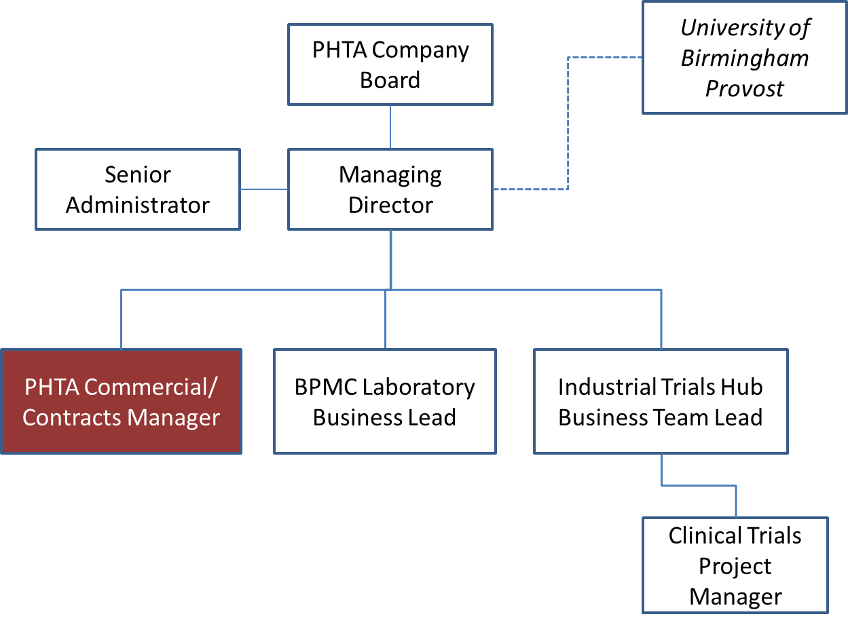
Main duties

- On behalf of PHTA Ltd, you will be responsible for establishing and managing key contract arrangements between
- the University and PHTA Ltd
- PHTA Ltd and commercial industrial customers
- PHTA Ltd and suppliers
- Responsible for the preparing and negotiating of complex contracts and to draft bespoke contract documentation in response to specific needs:
- Responsible for ensuring effective and professional delivery of contracts review and advisory services, in accordance with agreed review and negotiation frameworks, providing fully worked out, risk assessed solutions.
- Responsibility for drafting, reviewing and negotiating commercial / research contracts; these are likely to be high value, complex, or strategically important contracts with major, globally significant, customers.
- Resolution of complex contractual issues, taking forward negotiations with stakeholders to arrive at mutually agreeable positions.
- Working with colleagues in BPMC and the University Trials Units where appropriate:
- develop commercial pricing for key services, benchmarking and testing these against the market
- Be responsible for assessing the financial value of contracts, and
- Assess and agree contract scope of works, milestones and other deliverables
- You will be setting the professional standard and the collaborative nature by which the company undertakes its business and will be expected to maintain the highest quality of service delivery and a professional, customer-focused ethos.
- Build and maintain strong working relationships, and at all times work collaboratively with, colleagues across the University to ensure the needs of the PHTA, the University as partner and the customer are met.
- Ensure that service complaints or concerns are dealt with in a consistent and robust manner, taking personal responsibility for complaint resolution and applying lessons learned to drive process improvement where possible/applicable.
- Work closely with the Managing Director, ITH Lead and the Head of R&KE Contracts within the University to implement an appropriate contracts framework between the University and PHTA Ltd
- Establish service standards and KPIs and ensure these are continually monitored and where appropriate make changes to ensure that the expectations of both the University and industry customers are met.
- Where appropriate, undertake training, development and the sharing of good practice with appropriate University teams (e.g. in contracts, governance, ethics, clinical trials management) and with your own team as that develops, setting the professional standard and the collaborative culture in which the team operates and acting as a role model for the team in terms of output quality, service delivery and a customer-focused ethos.
- Take a proactive role in promoting teamwork and integrating operating processes between PHTA Ltd and the University.
- Undertake investigation and analysis of specific legal or regulatory changes, and the implications of these on collaboration and agreements.
Required Knowledge, Skills, Qualifications, Experience

- Educated to degree standard.
- Extensive knowledge of contract law and practical experience in drafting and reviewing contracts, preferably including experience gained in a commercial contract role within the pharmaceutical or health sector.
- Good knowledge and experience of contracting with or in the pharmaceutical industry.
- Experience of assessing value and pricing of commercial services
- Understanding of research governance, data handling and other key requirements associated with clinical trials contracts and delivery
- Excellent, demonstrable contract development, management and delivery skills
- Experience of negotiating complex agreements for commercial / collaborative projects having to balance the needs of multiple stakeholders and assess and manage risks appropriately
- Good commercial appreciation of the value of world-class clinical trials capability to the pharmaceutical industry and ability to maximise contract value
- Strong and proven ability to problem solve especially when under pressure
- Excellent stakeholder and partnership management skills and ability to align needs of customers and the business accordingly.
- Well organised, commercially-focussed, with the ability to prioritise quickly.
- Excellent communication and influencing skills including proven track record of engaging effectively with all levels of management and internal/external customers to get results quickly; able to communicate decisions and recommendations appropriately to stakeholders internally and externally
- Highly motivated self-starter; ability to initiate and manage work with sense of urgency and leadership.
- Proven ability to deliver service quality improvements, with a track record of using KPIs to monitor service standards and drive innovative service quality improvement

Dimensions
This is a senior role within a new business and will require the exercise of strong leadership and personal initiative within and beyond the Company.
Will require day to day liaison with the Managing Director in setting the strategic and commercial intent for the business
Will require tact and diplomacy in engagement with key academic and professional service leads within the University.
Problem solving and decision making
The role-holder is expected to work independently on tasks that carry significant value and risk to the Company and the University.
You will be expected to undertake the core of your work around contract drafting, negotiation, providing advice and engaging with external clients and University partners without reference to others, only escalating to the Managing Director if matters are not able to be resolved quickly or effectively.
Internal and external relationships

The post holder will be expected to liaise on a regular basis with colleagues from across the University and in particular: the senior academic staff leading or involved in clinical trials or diagnostics work; University Trials Unit staff; Research Contracts Team management and staff and other professional services staff.

Externally, you will be responsible for maintaining relationships with key contract and commercial leads at industry partners and with suppliers

Our values and behaviours

- Works effectively with others, using guidance, support and advice as appropriate  - Understands the broader context and how own work impacts more widely | - Continuously reflects on work practices, and proactively recommends and makes improvements  - Actively seeks and participates in learning and development opportunities | - Reliable and highly motivated  - Provides consistently high level of customer service | - Self-aware and understands impact of own behaviours on self and others and how others’ behaviour impacts them  - Embraces different perspectives | - Flexible and adaptable in approach and takes responsibility for achieving goals  - Seeks help and advice when needed, and is willing to take calculated risks when appropriate and learn from mistakes

